Page no -12
Achievement of the Year (2022-23)

School is a place which channelizes a student's energy engages and gets best out of them and engages them in a lot of activities throughout the year. Students of H.M. Sr. School participated in various activities during the session 2022-23, where students came out with flying colours and outshown themselves. Lipsita, Kashish Rajak, Kajal Tiwari under the guidance of Ms Neelam Sharma, Vice Principal bagged the second position in Science Exhibition to North Cap University.
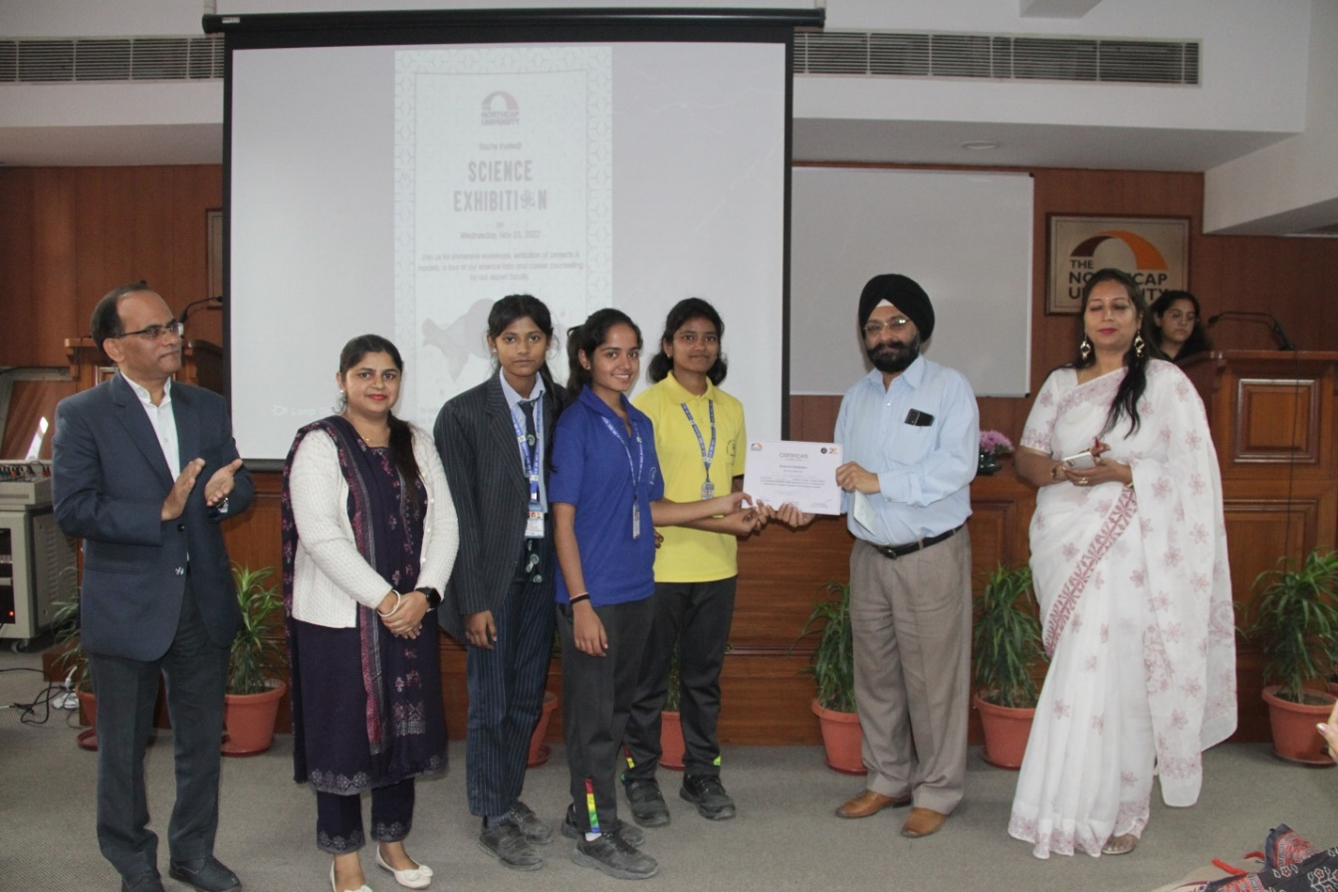

Students class XI Muskan, Tanya, Aastha, Khushi participated in Rangoli Competition (Intra-school) and were bestowed with memento on gaining the first position.
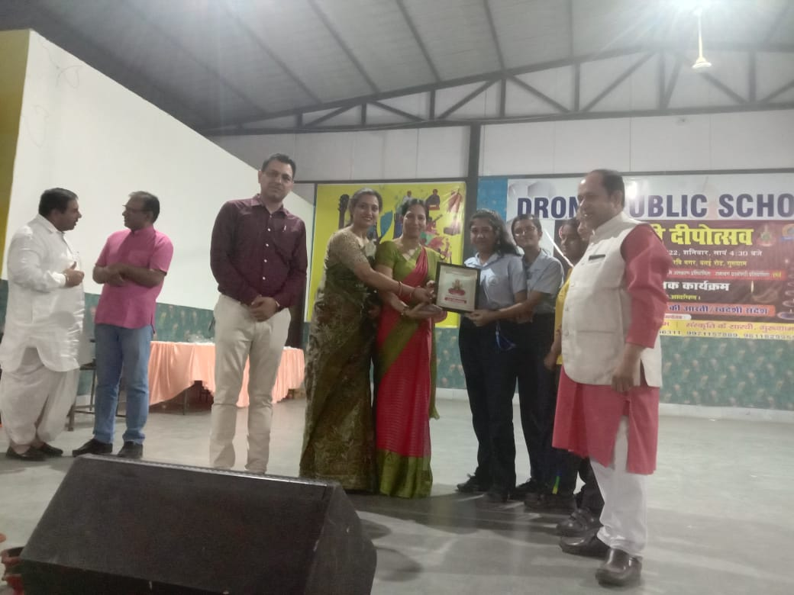

Sandhya of class V achieved the second position in clay modelling and Lipsita of class XI Science got the third position in District Declamation Competition organized by District Council for child welfare. Kashish Rajak of class XII Science participated in Intra School Diya Making Competition and bagged the second position with a Trophy.
There was a Science Quiz conducted by RSS (Tohana) in our school in which Rishabh of class VII & Siddharth of class VI A got merit.
There was Mahatma Gandhi Hindi Bhasha Pratiyogita held in our school in which Sukanya Thapa of class IX B achieved Gaurav Ratna in Hindi Language.

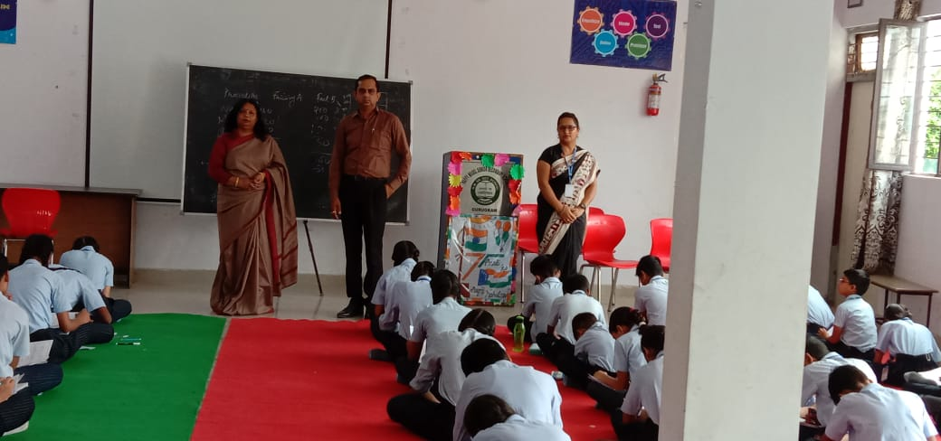
Rashtriya Shiksha Samiti (Tohana) conducted Vigyan Pratiyogita on 7 Feb 2023. Our young innovators (class V – IX) participated in the Quiz. Students came out with flying colours.
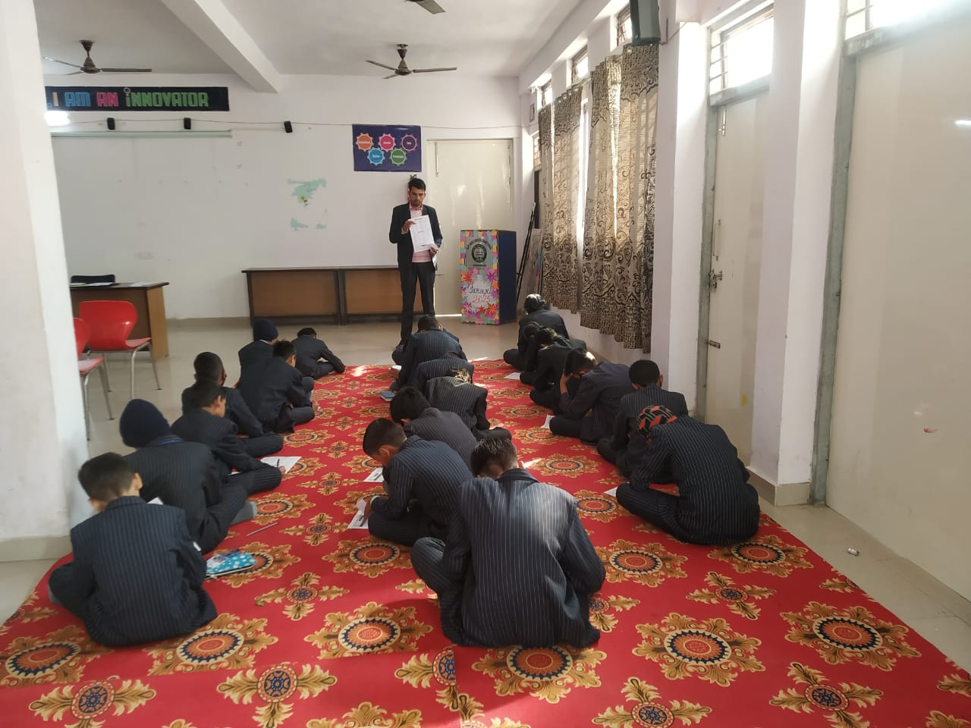
Students of the school added one more feather in the cap of glory. Zee Mind Wars conducted an offline quiz pertaining General knowledge and Current Affairs on 8 Feb 2022. Students clinched Amazon Vouchers and Merit Certificates.
